Welcome!
Date
Name
Spouse
Address
City
State Zip _________
Email

Please Contact By
❑ Card  Phone  Visit

Telephone Best Time to Call
Home ______________
Work ______________

Guest: First Time Second Time
Are you a church member: yes no
Church
City, State

Circle Appropriate Age/Grade Group(s)
Preschool: Ages: B-1 2-3 4-5
Children: Grades: K 1 2 3 4 5 6
Youth: Grades: 7 8 9 10 11 12
Adults: Ages:18-29 30s 40s 50s 60s+

How did you learn about our church?
Newspaper Friend Yellow Pages Mail
Other

I am a guest of:

New in the Community? Yes No
Names & ages of children at home

Weekly Service & Activity Schedule

Oct 22, 2017
9:45 a.m. Sunday School
11:00 a.m. Worship Service
6:00 p.m. Evening Video – Burden of Envy

Week of Oct 22, 2017
Wednesday 6:30 pm……………..……….Meal/Bible Study
Thursday 10:00 am……………………….Adult Fellowship
Friday 6:30 pm……………..……………..Men’s 42 Night
October
21…………………………..………..First Aid/CPR Class
26…………….…………………..First Aid/CPR Class II
26…………………………………….….Adult Fellowship
29………………..…………….High Attendance Sunday
November
5……………………….……..New Commandment Kids
5…………………………Turn Clocks Back (Fall Back)
9…………………………………………Adult Fellowship
11……………………………………………Harvest Stew
HARVEST STEW
Saturday, Nov 11

You won’t want to miss this! Gospel music, delicious beef and veggie stew, 42, games for the kids and so much more!!

Singing starts around 4:00
Stew serving begins about 5:30
42 and kid’s activities start at 6:30

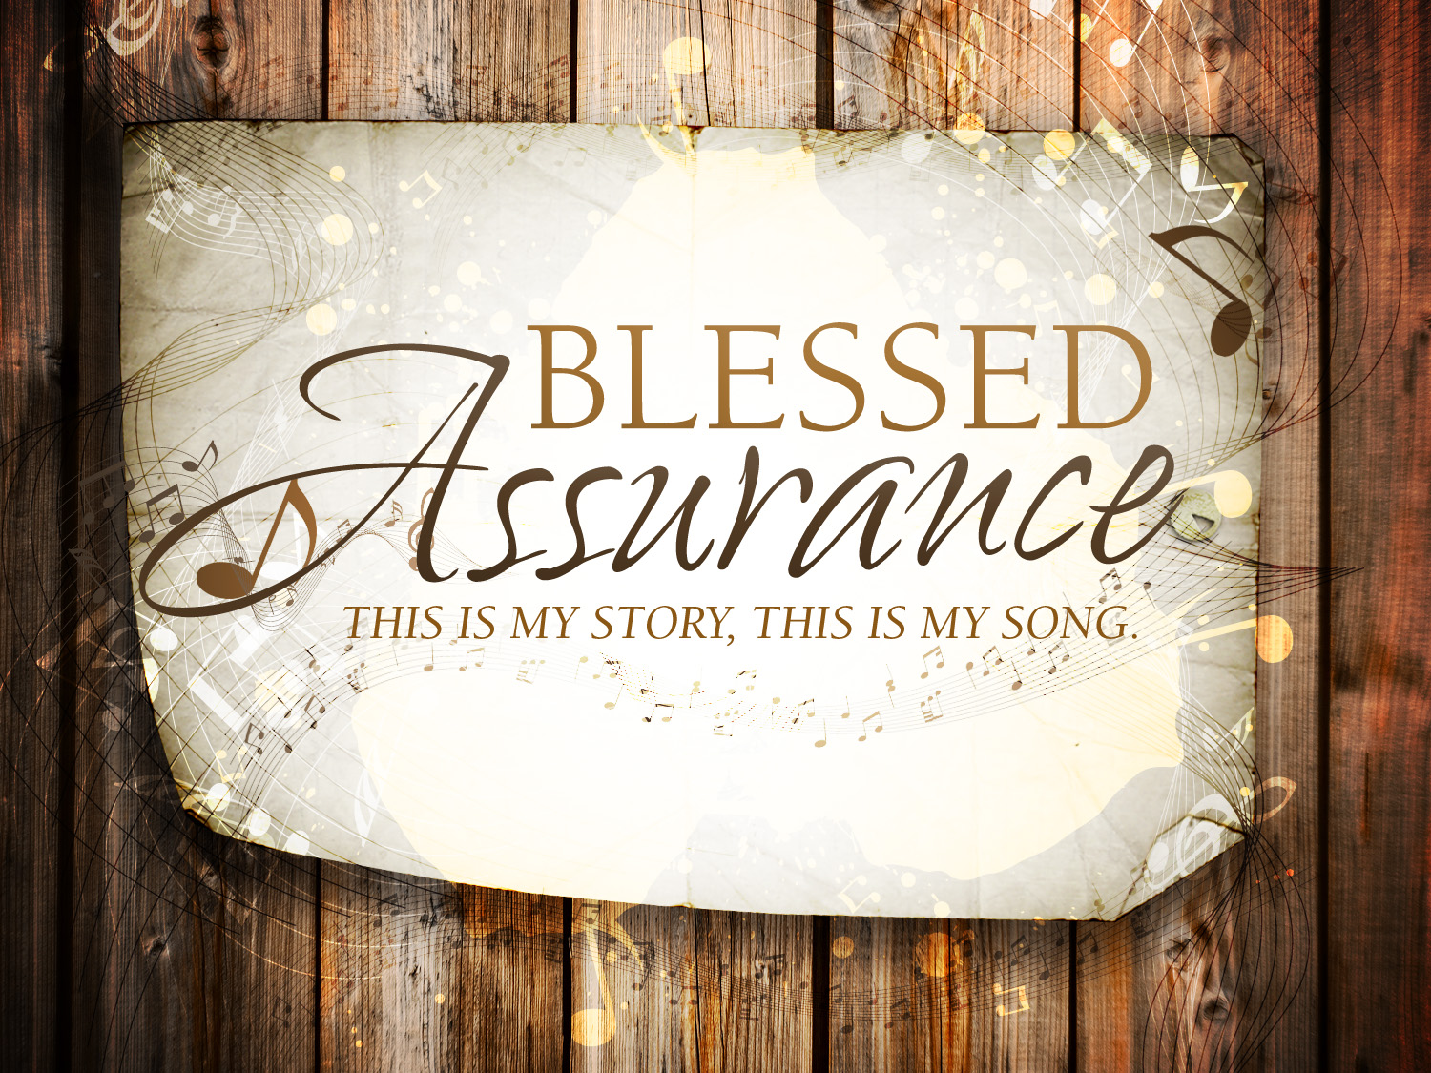

Knobbs Springs Baptist Church

Oct 22, 2017

Church Information:

KnobbsSpringsBC.com KnobbsSpringsBaptist@gmail.com

1662 CR 305, McDade, Texas 78650 512-273-2743

David Atwood, Pastor Cell 512-470-5098

Patti Radford, Office Manager Cell 512-968-7821

